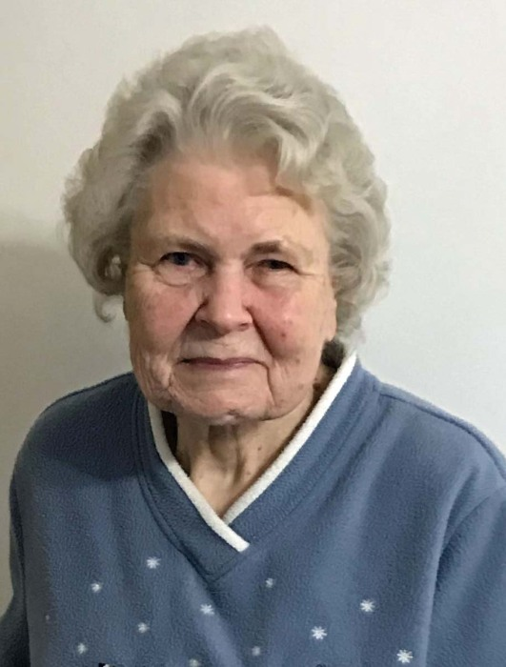

MILLER, BEVERLY A. of Waterford, passed away February 21, 2022 at 82 years of age. Loving wife of Forest for 60 years; cherished mother of Rodger (Dawn) Miller, Douglas Miller, Todd (Delores) Miller, Dave (Shawn) Miller, and Michelle (Lisa Thompson) Miller; grandmother of Jesse, Samuel, Justine, and Sarah; sister of Don (Mary) Martin. Beverly was a wonderful wife, mother, and grandmother. She was famously known for baking; baking; and baking. She had her own little cottage industry of selling cookies, breads, rolls, cinnamon buns, and coffee cakes all of which she never quite charged enough. Her garage sales were popular only for the baked goods. Her family was her universe and she loved them unconditionally. She will be forever missed by her loving family. A memorial visitation will be held Monday, February 28, 2022 from 3-6 PM at COATS FUNERAL HOME-WATERFORD. To post a tribute, visit www.CoatsFuneralHome.com.

